 |  | Semarak International Journal of Machine Learning |  | 
Journal homepage:
https://semarakilmu.my/index.php/sijml/index
ISSN: 3030-5241
Development of A Prototype for Livestock Monitoring using IoT Sensor
Siti Fatia Mohamad Ali^{1,*}, Sabrina Milan¹ , Norbaizura Mokhtar¹

¹ | Department of Information Technology and Communication, Politeknik Kuching Sarawak, Malaysia
ARTICLE INFO |  |  | ABSTRACT
Article history:  Received 30 December 2025  Received in revised form 23 February 2026  Accepted 10 May 2026  Available online 8 June 2026 |  |  | Effective livestock monitoring plays an increasingly important role in improving herd management, reducing avoidable losses, and supporting the transition toward precision-based agricultural practices. In Sarawak, the lack of continuous and dependable monitoring systems—especially in rural areas where digital infrastructure remains limited—has drawn attention to the need for more innovative approaches to livestock surveillance. In response to this challenge, the present study aims to introduce an IoT-driven tracking prototype designed to facilitate real-time observation of goat movement and physiological status in open-grazing environments. The prototype was field-tested at Borneo Happy Farm, an agro-tourism and livestock site that offers a realistic and practical environment for evaluating new monitoring technologies. The system brings together the Global Positioning System (GPS) NEO-6 u-blox 6 module for precise geolocation capture and the ESP32 LoRaWAN Heltec V3.2 microcontroller to enable long-range, low-power communication. A rechargeable battery supports extended operation, while Starlink satellite connectivity makes it possible to maintain stable data transmission even in locations where terrestrial networks are unreliable. The prototype gathers both positional information and peripheral oxygen saturation (SpO₂) readings and relays them through LoRaWAN to a cloud-based repository for further analysis. To assist users, a Looker-based dashboard provides real-time maps, movement histories, and spatial behaviour patterns, offering an intuitive tool for farm operators to interpret and act upon field data. Findings from the deployment at Borneo Happy Farm suggest that the monitored goats displayed normal grazing patterns, and their SpO₂ levels remained consistently stable across all activity zones, indicating no signs of physiological stress. Moreover, performance assessments show that the system delivered reliable data transmission, responsive sensor behaviour, and efficient power use. Taken together, these outcomes indicate that the proposed prototype is both feasible and effective for livestock monitoring in remote agricultural settings. Overall, the findings demonstrate the feasibility of integrating GPS-based movement tracking and SpO₂ monitoring within a low-power wearable platform, providing a preliminary foundation for future precision livestock monitoring systems in rural settings, subject to further validation across larger herds and diverse farm conditions.
Keywords:
GPS sensor; looker; SpO2; livestock monitoring; ESP32 LoRaWAN

1. Introduction

The livestock sector represents an important economic pillar in Sarawak, playing a key role in sustaining rural livelihoods, strengthening food security, and supporting broader regional development objectives. Recent initiatives spearheaded by the Regional Corridor Development Authority (RECODA) have highlighted livestock as one of the state’s priority growth industries, with considerable scope for modernization through enhanced productivity, improved herd management, and the integration of emerging digital technologies. At the same time, reports from the Department of Veterinary Services (DVS) Sarawak indicate that farmers in rural communities continue to face significant operational challenges, such as livestock theft, predation, straying into restricted areas, and the absence of continuous monitoring tools. These issues frequently lead to financial losses and hinder the shift towards more data-driven and precision-focused livestock systems. Moreover, in remote areas where grazing territories are extensive and network coverage is limited, the lack of real-time surveillance further complicates farm management and restricts operational efficiency. In recent years, the adoption of Internet of Things (IoT) technologies has been widely regarded as a promising avenue for addressing such challenges. As suggested in the literature, IoT-enabled solutions have the potential to automate livestock monitoring, improve welfare conditions, minimise labour demands, facilitate early detection of abnormal events, and support more informed decision-making. Nevertheless, many existing commercial platforms depend heavily on terrestrial communication networks, which are often unreliable or unavailable in rural Sarawak. This observation points to a clear need for a monitoring framework that is capable of operating effectively in low-infrastructure settings.
In response to this gap, the present study introduces an IoT-based livestock tracking prototype designed to support real-time monitoring of goat mobility and physiological status under open-grazing conditions. The system combines the GPS NEO-6 u-blox 6 module for precise geolocation capture with the ESP32 LoRaWAN Heltec V3.2 microcontroller to enable long-range, low-power data transmission. A rechargeable power system allows for prolonged field deployment, while Starlink satellite connectivity provides a stable communication channel where conventional networks are absent. Among physiological indicators, peripheral oxygen saturation (SpO₂) was selected as the primary health parameter in this study due to its non-invasive nature and its relevance as an indirect indicator of respiratory efficiency and systemic stress. In small ruminants, variations in SpO₂ have been associated with heat stress, respiratory compromise, and reduced physical well-being, particularly under outdoor grazing conditions. Compared to parameters such as blood chemistry or respiration rate, SpO₂ sensing offers a practical balance between physiological relevance, sensor simplicity, and energy efficiency. As this study represents an early-stage prototype evaluation, SpO₂ was prioritised to assess the feasibility of continuous physiological monitoring in a wearable form factor, with the understanding that additional biosignals can be integrated in subsequent development phases. A Looker-based dashboard has been developed to visualise movement paths, historical trajectories, and spatial behaviour patterns, offering users an accessible tool for interpreting field data.
This study advances existing IoT-based livestock monitoring research by focusing on field-level feasibility rather than algorithmic complexity or large-scale system generalisation. Unlike many prior studies that evaluate GPS tracking or physiological sensing independently or under simulated conditions, the proposed prototype integrates spatial tracking and physiological monitoring within a single wearable platform and evaluates its performance under real open-grazing conditions in rural Sarawak. In addition, the use of a LoRaWAN–satellite communication pathway addresses connectivity constraints commonly encountered in remote livestock farms, where terrestrial networks are unreliable or unavailable. Rather than proposing a fully mature commercial solution, this work emphasises practical system integration, deployment realism, and data interpretability, thereby contributing empirical evidence on how low-cost IoT components perform in real farm environments.

2. Related Works

Previous studies indicate that Internet of Things (IoT) technologies now play a central role in modern livestock monitoring by addressing long-standing challenges associated with animal health evaluation, behavioral assessment, and geolocation tracking. As digital agriculture continues to mature, it has been widely reported that IoT-driven monitoring systems contribute to improved animal welfare, reduced livestock loss, and more evidence-based farm management practices. Early investigations in this area proposed decentralized and secure data acquisition architectures for IoT-based livestock monitoring, drawing attention to the security vulnerabilities and scalability limitations of centralized systems, particularly in large-scale deployments [1]. To mitigate these issues, distributed and blockchain-inspired frameworks were introduced, with the aim of strengthening data integrity and system robustness, especially in rural settings where communication reliability is often inconsistent.
Subsequent research expanded on these architectural concepts by developing IoT platforms based on wireless sensor networks (WSNs) for livestock health monitoring [2]. These studies demonstrated that WSN-based systems can effectively capture physiological and environmental parameters, including body temperature and ambient conditions, thereby enabling early-warning mechanisms for farmers. However, it was also noted that limited coverage and the need for resilient multi-hop communication remain significant challenges in remote grazing regions. In response to efficiency and labor constraints, later work explored the use of wearable sensing technologies for automated behavior recognition. In particular, a wearable three-dimensional sensor node was introduced to reliably classify dairy cow activities such as standing, lying, walking, and feeding, showing that accelerometer-based wearables can substantially reduce manpower requirements in commercial livestock operations [3].
More recent contributions have presented integrated IoT-based livestock monitoring systems that combine GPS, temperature sensors, and magnetometers within wearable platforms supported by both LoRa and satellite communication technologies [4]. This dual-network approach has been shown to enable continuous real-time monitoring in areas without terrestrial network coverage, thereby overcoming a major limitation of earlier systems. Along similar lines, attention has been drawn to the need for monitoring solutions tailored to free-grazing and extensive livestock systems. A mobile-based e-Farm prototype, for example, focused on real-time tracking and grazing boundary delineation to reduce animal loss and mitigate human–livestock conflicts in open-grazing environments [5]. At the same time, recent studies have increasingly pointed to the adoption of intelligent monitoring technologies as a means of improving production efficiency, animal health management, and overall farm performance, primarily by reducing reliance on manual observation and labor-intensive practices [6].
Further investigations have shown that IoT-based health surveillance systems are capable of delivering continuous real-time monitoring of physiological and behavioral indicators through networked sensors and wireless communication infrastructures. Nevertheless, these studies also highlight unresolved challenges related to energy efficiency, connectivity reliability, and scalability in rural deployments [7]. Complementary findings suggest that wearable collar technologies consistently capture movement, activity, and physiological data, providing meaningful insights into livestock behavior and welfare under real farm conditions [8]. In parallel, research in precision livestock farming has demonstrated that sensor-based monitoring systems enhance the efficiency of animal health and productivity management, thereby supporting more informed, data-driven decision-making at the farm level [9]. Moreover, it has been demonstrated that database-centric approaches combining inertial sensor data with machine learning algorithms can improve the accuracy of livestock activity recognition and behavioral classification, reducing dependence on manual and subjective assessment methods [10].
Recent reviews increasingly emphasize wearable and IoT-based sensing technologies as the technological backbone of precision livestock farming and real-time animal health monitoring. One comprehensive review outlined how wearable sensor platforms incorporating accelerometers, temperature sensors, and positioning modules enable continuous acquisition of physiological and behavioral data using low-cost, low-power devices suitable for long-term deployment [11]. Evidence from field-based studies further supports these findings, showing that IoT-enabled wearable sensors can reliably collect activity and movement data over extended periods in operational farm environments, confirming their applicability beyond laboratory settings [12]. Advances in biosensing technologies have further reinforced the value of wearable-based monitoring, with recent developments enabling the measurement of vital indicators such as body temperature, heart rate, and stress-related parameters, thereby facilitating early detection of illness and abnormal behavior [13].
From a communication perspective, it has been demonstrated that low-power wide-area network technologies are particularly well suited to livestock monitoring in rural and free-grazing environments. In particular, LoRaWAN-based systems have been shown to support long-range data transmission with minimal energy consumption, making them appropriate for deployments where conventional cellular or Wi-Fi connectivity is unavailable or unreliable [14]. Beyond individual sensor nodes, broader studies have stressed the importance of integrating data analytics and digital platforms within smart farming ecosystems to transform livestock production into a more efficient and data-driven process [15]. Collectively, these findings highlight the need for prototype systems that not only collect sensor data but also support scalable data management and decision-making at the farm level.
Building on this body of work, the present study addresses key limitations related to connectivity, system integration, and real-world deployment. While earlier systems often examined livestock movement or physiological monitoring in isolation or relied on stable terrestrial networks, this work integrates GPS-based movement tracking with real-time physiological monitoring using a low-power, long-range communication architecture supported by satellite connectivity. Through field deployment in a rural farm environment, the proposed system demonstrates how the integration of spatial and physiological data offers a more comprehensive, practical, and scalable approach to precision livestock monitoring. Table 1 summarizes the key limitations identified in existing IoT-based livestock monitoring studies and highlights the research gaps that motivate the development of an integrated, field-ready monitoring solution.

Table 1
Summary of research gaps
Ref. | Main Focus | Key Contribution | Limitation Identified | Research Gap
[1] | Decentralized IoT architecture | Secure, blockchain-inspired data collection | Limited sensing integration and field validation | Lack of full end-to-end livestock monitoring deployment
[2] | WSN-based health monitoring | Effective monitoring of physiological and environmental data | Coverage and multi-hop communication issues | Need for long-range, reliable communication in remote grazing areas
[3] | ML-based activity database | Improved activity detection using collar data | Offline analysis, no real-time deployment | Absence of real-time, edge-integrated analytics
[4] | Wearable collar technologies review | Comprehensive overview of wearable sensing | Fragmented and vendor-specific implementations | Need for unified, interoperable monitoring frameworks
[5] | Wearable 3D behavior sensor | Accurate recognition of cow behaviors | No spatial tracking or health parameter fusion | Lack of multimodal physiological–spatial integration
[6] | IoT health surveillance review | Overview of real-time health monitoring systems | Energy efficiency and scalability challenges | Need for low-power, scalable architectures
[7] | Multi-sensor IoT with LoRa + satellite | Continuous monitoring without terrestrial networks | Limited analytical fusion of collected data | Insufficient holistic data integration
[8] | Decentralized data collection (blockchain) | Improved resilience and data integrity | Focus on architecture rather than sensing outcomes | Lack of application-level livestock monitoring validation
[9] | Free-grazing e-Farm tracking | Location tracking and grazing boundary control | No physiological health monitoring | Absence of health-aware free-grazing systems
[10] | Precision livestock farming applications | Data-driven livestock productivity management | Systems often modular and fragmented | Need for integrated, field-ready PLF solutions
[11] | Wearable sensor systems review | Identified low-cost, low-power sensing platforms | Mostly conceptual and review-based | Limited prototype implementation and validation
[12] | Field deployment of wearable sensors | Validated long-term on-farm monitoring | Focused mainly on behavior and movement | Lack of combined health–movement analysis
[13] | Biosensing technologies review | Advanced sensors for vital sign monitoring | Limited integration with IoT platforms | Need for biosensors integrated into IoT wearables
[14] | LoRaWAN-based livestock monitoring | Long-range, low-power communication | Limited sensing diversity | Need for multimodal sensing over LPWAN
[15] | Smart farming and big data platforms | Emphasis on analytics and digital ecosystems | Weak linkage to edge-level sensing systems | Gap between sensor-level data and farm-level decision support

3. Prototype Development

The prototype development process was structured to design, assemble, and validate an IoT-enabled livestock monitoring system capable of capturing real-time geolocation and physiological parameters under open-grazing conditions. The development followed a systematic engineering approach involving hardware integration, firmware programming, communication testing, power optimization, and interface development. Each component was selected based on operational reliability, low-power characteristics, and suitability for deployment in remote agricultural environments.

3.1 Hardware Architecture

The core hardware architecture consisted of four major components:
1. GPS NEO-6 u-blox 6 module for geolocation tracking
2. ESP32 LoRaWAN Heltec V3.2 microcontroller for data processing and transmission
3. SpO₂ sensing module for physiological monitoring
4. Rechargeable lithium-ion battery system for sustained field operation

The GPS NEO-6 u-blox 6 was chosen due to its high sensitivity, low acquisition time, and compatibility with long-duration outdoor applications. The ESP32 Heltec LoRaWAN V3.2 served as the main processing unit, integrating a dual-core microcontroller, onboard LoRaWAN transceiver, and OLED display for debugging during testing. The SpO₂ sensor was included to measure peripheral oxygen saturation, offering a non-invasive method to assess the animal’s physiological condition. All components were mounted within a custom-designed protective casing that could withstand environmental exposure while remaining lightweight enough for goat deployment.

3.2 Firmware and Software Integration

Firmware development was conducted using the Arduino IDE environment, enabling efficient (C/C++-based) program control over sensor reading intervals, LoRaWAN packet assembly, and error handling. The firmware was responsible for acquiring GPS coordinates, reading SpO₂ values, timestamping each record, and managing transmission scheduling. LoRaWAN communication parameters (spreading factor, bandwidth, transmission power) were optimized to achieve a balance between data reliability and power efficiency.
A cloud-based data pipeline was then established. The LoRaWAN data packets were forwarded from the ESP32 node to a Starlink satellite gateway and subsequently delivered to a cloud server. A storage and retrieval mechanism was configured using a structured database schema that allowed efficient indexing of device ID, timestamp, coordinates, and physiological readings.

3.3 Data Visualization Platform

A Looker Studio dashboard was developed to visualize real-time and historical data. The dashboard presented:
• Real-time GPS positioning
• Historical movement trails
• Heatmaps of grazing density
• SpO₂ trends across time
• Device health metrics (battery, signal strength)
This interface provided an intuitive platform for farmers and field operators, reducing the complexity of interpreting raw IoT data. It also allowed multiple devices to be monitored simultaneously.

3.4 Power Management and Durability

To ensure long-term deployment, the prototype incorporated a rechargeable battery optimized for low-current draw. Sleep-mode configurations were implemented in the firmware, allowing the device to enter low-power states during idle periods. Component arrangement within the casing minimized mechanical stress, while weather-resistant materials protected internal circuitry from moisture, dust, and impact during animal movement.

3.5 Field Assembly and Animal Deployment

The prototype was mounted using an adjustable collar designed to balance secure sensor placement with animal comfort. During field sessions, no visible signs of discomfort, altered gait, or avoidance behaviour were observed, suggesting that the device did not interfere with routine grazing activities over short-term deployment. Nevertheless, motion artefacts were occasionally reflected in isolated SpO₂ outliers, highlighting the sensitivity of optical sensors to collar movement and contact pressure. These observations underscore the importance of improved sensor housing, attachment stability, and signal-quality validation for long-term wearability in future iterations.

3.6 Data Collection

The data collection process for this study was designed to obtain reliable, continuous, and high-resolution information on the movement and physiological condition of goats under open-grazing conditions. The prototype system—comprising a GPS NEO-6 u-blox 6 receiver, an ESP32 LoRaWAN Heltec V3.2 microcontroller, a rechargeable power unit, and integrated SpO₂ sensing—was deployed at Borneo Happy Farm, Sarawak. This field location was selected because it represents a realistic operational environment where livestock graze freely and where network connectivity, terrain diversity, and animal movement patterns provide an appropriate test scenario for IoT-based monitoring systems.

3.7 Instrumentation and Sensor Deployment

Each device was securely attached to the neck region of a selected goat using an adjustable collar strap that ensured comfort without restricting movement. The GPS module captured geolocation coordinates at predefined intervals, while the SpO₂ sensor recorded peripheral oxygen saturation as an indicator of physiological well-being. The ESP32 LoRaWAN unit managed data acquisition, timestamping, and wireless transmission. All sensors were calibrated prior to deployment to ensure consistency in measurement accuracy.

3.8 Transmission and Cloud Storage

Data packets containing timestamp, latitude, longitude, SpO₂ value, and device identification number were transmitted via LoRaWAN to a Starlink satellite-enabled gateway. This transmission pathway was selected to evaluate the performance of long-range, low-bandwidth communication in areas where cellular coverage is inconsistent or unavailable. Upon receipt, the gateway relayed data to a cloud-hosted server through secured HTTPS channels. All incoming data were automatically logged and stored in a structured database format for subsequent analysis.

3.9 Observation Period and Recording Frequency

Data collection was conducted over multiple field sessions, with each session lasting several hours to capture diverse grazing behaviours and movement patterns. The sampling frequency for GPS and SpO₂ measurements was set to ensure adequate temporal resolution while balancing battery consumption. This approach allowed the system to record meaningful movement trajectories and physiological trends without compromising energy efficiency.

3.10 Environmental and behavioural context

During the observation period, environmental conditions such as terrain type, vegetation density, and weather changes were noted to contextualize variations in movement patterns. Although the system primarily collected automated sensor data, visual observations were conducted periodically to confirm normal animal behaviour and to ensure that devices remained properly attached.

3.11 Data validation and preprocessing

Raw data were inspected for missing values, GPS drift, timestamp irregularities, and sensor noise. Invalid or incomplete records were filtered out using predefined criteria. Geospatial cleaning was applied to remove implausible GPS jumps, and SpO₂ readings were validated against known physiological ranges for small ruminants. The cleaned dataset was then structured into analytical formats suitable for generating heatmaps, movement paths, speed estimations, and physiological-behavioural correlation analyses.

4. Result and Discussion
4.1 Data overview

The dataset consists of 272 records collected from three devices (ID 1, 12, and 13) between 12 February 2025 and 12 April 2025. Each record includes timestamp, device ID, heart rate, SpO₂, temperature, battery voltage, battery percentage, and—where available—GPS latitude and longitude.
Out of 272 records:
• 126 records contain valid GPS coordinates.
• 190 records contain SpO₂ readings.
• 199 records contain heart rate values.
GPS data are available mainly for devices 12 and 13, making these collars the primary focus for movement analysis, while all three devices contribute to physiological analysis.

4.2 SpO₂ Trends Over Time

Figure 1 (SpO₂ over time by device) shows peripheral oxygen saturation for each collar across the monitoring period.

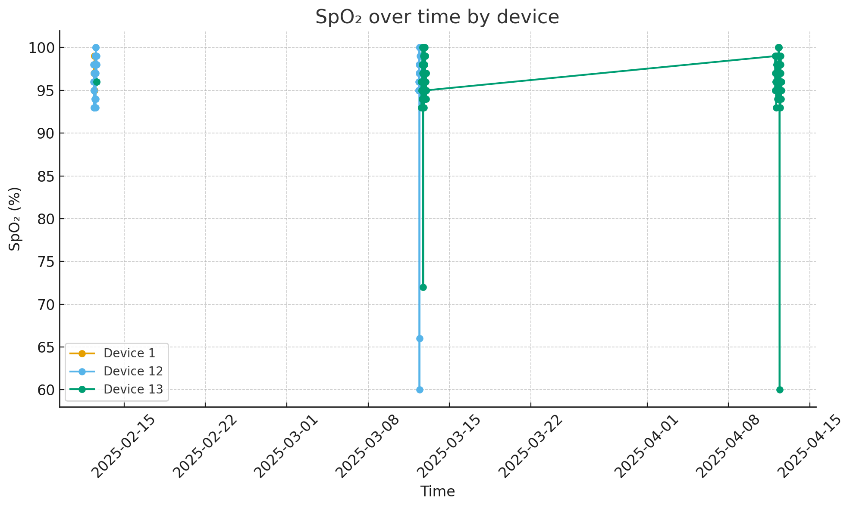
Fig. 1. SpO₂ over time by device
Key observations:
Device 1 recorded 17 SpO₂ values with a mean of about 97%, ranging from 95% to 99%.
Device 12 recorded 58 values with a mean around 95%, with most readings between 95% and 98%, and a few outliers down to 60%.
Device 13 recorded 115 values, with an average close to 96%, again mostly in the 95–99% band, with occasional low outliers near 60%.

For the majority of the dataset, SpO₂ values clustered between 95% and 99%, which aligns with physiological ranges reported for healthy small ruminants under non-stress conditions. Occasional isolated values near 60% were observed; however, these were not sustained over time and did not coincide with behavioural anomalies or repeated patterns. Such transient deviations are therefore more plausibly attributed to sensor contact variability or motion-induced artefacts rather than genuine hypoxic events. When interpreted against established physiological benchmarks, the SpO₂ data suggest that the monitored goats maintained stable respiratory function throughout the observation period.

4.3 Movement Distance and Activity Levels

Figure 2 (Daily distance travelled by device) summarises the total distance estimated from consecutive GPS points using the Haversine formula. The analysis was performed per device and per day:
• Device 12
o 12 February 2025: approximately 96 m of movement over 9 GPS records.
o 12 April 2025: approximately 50 m over 4 GPS records.
• Device 13
o 12 March 2025: about 486 m over 55 GPS records.
o 12 April 2025: about 518 m over 58 GPS records.

Instantaneous speeds derived from successive GPS fixes are very low on average (<0.1 km/h), with maximum values around 0.37 km/h for device 12 and about 1.08 km/h for device 13. The estimated daily movement distances and low average speeds observed in this study are consistent with grazing behaviour reported for goats in confined or semi-confined paddock systems, where animals typically alternate between short movement bouts and stationary feeding periods. The absence of long-distance displacement or sustained high-speed movement indicates that the animals remained within their intended grazing zones and were not exposed to significant disturbances during monitoring sessions.

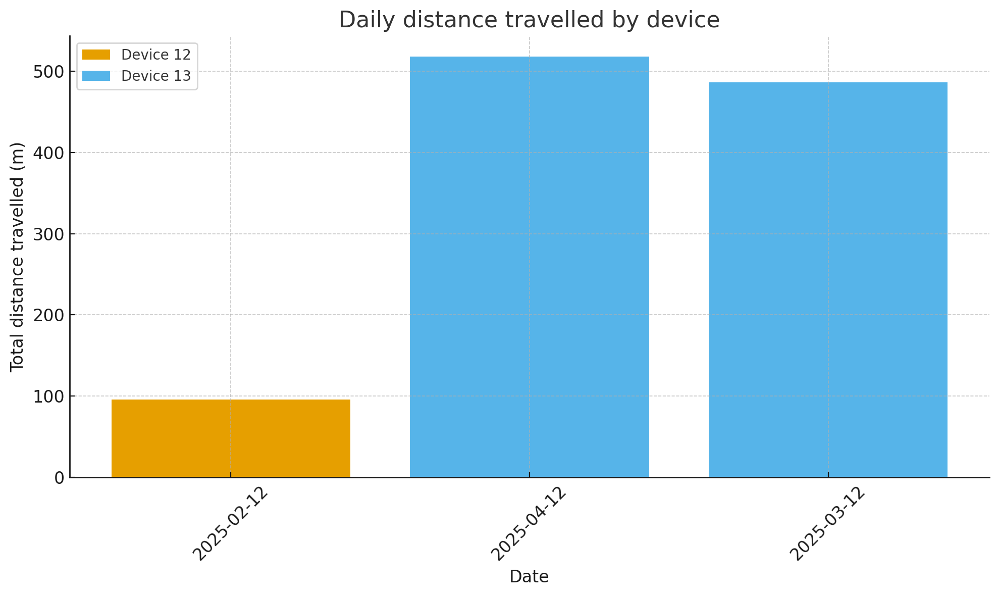
Fig. 2. Daily distance travelled by device

4.4 Spatial Distribution of GPS Points

Figure 3 (Spatial distribution of GPS points by device) plots all valid GPS locations for devices 12 and 13. The points form a compact cluster rather than widely dispersed tracks.
• Device 13 has the highest density of points, forming a central cloud of locations with small variation in latitude and longitude.
• Device 12 shows fewer points but occupies roughly the same spatial envelope.

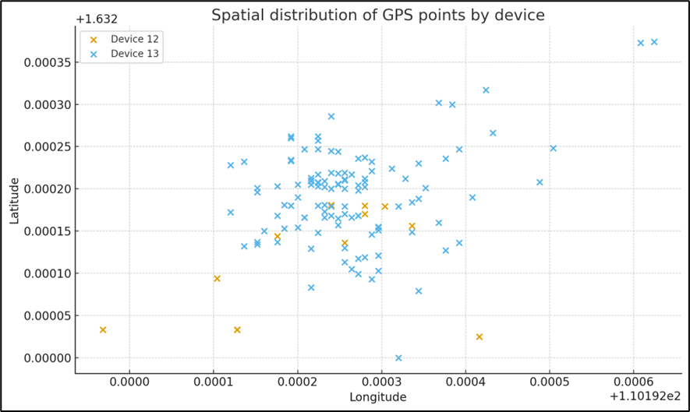
Fig. 3. Spatial distribution of GPS points by device

The tight clustering indicates that the animals grazed within a limited paddock area rather than roaming long distances. There is no evidence of abrupt jumps or coordinates far outside the main cluster, suggesting the absence of escape events or major GPS errors during the recorded sessions. This supports the geofencing interpretation that the goats stayed within their intended grazing boundary during data collection.

5. Discussion

The combined GPS and SpO₂ analysis provides insight into both behavioural and physiological aspects of the monitored goats while simultaneously demonstrating the performance of the prototype system.
First, the movement results indicate that the goats exhibited typical grazing behaviour: low daily displacement (hundreds of metres at most within a session), slow average speeds, and movement confined to a relatively small spatial area. This is consistent with free-grazing in a fenced or bounded pasture and suggests that the animals did not experience major disturbances or escape attempts during the monitoring period.
Second, SpO₂ trends remained stable around 95–99% for all three devices, with only sporadic low outliers. In the absence of sustained desaturation episodes or clear temporal clustering of low values, these outliers are more plausibly explained by sensor contact issues—such as collar movement, dirt, or transient loss of optical signal—than by true respiratory impairment. Taken together, the data suggest that the animals were not under significant physiological stress during the field trials.
From a system perspective, the presence of continuous GPS tracks and regular SpO₂ readings across multiple days indicates that the prototype was able to acquire, timestamp, and transmit both geolocation and physiological data reliably. The fact that movement patterns and health indicators are coherent and biologically plausible further supports the integrity of the sensing and communication pipeline. The low average speeds and short total distances also reinforce that the temporal sampling and power-saving strategy are adequate for grazing livestock, where rapid, continuous high-speed motion is rare.

However, two limitations should be acknowledged. First, the number of monitored animals and days is still modest; larger-scale deployments will be needed to fully characterise behaviour across seasons, ages, and management regimes. Second, the occurrence of low SpO₂ outliers highlights the need for improved sensor mounting or signal-quality checks to automatically flag and discard artefactual readings. It is important to note that the findings are derived from a single farm deployment involving a limited number of animals and observation sessions. Although this setting provides valuable realism, it does not capture the variability present across different farm layouts, grazing regimes, animal breeds, or climatic conditions. Consequently, claims regarding suitability for rural livestock systems should be viewed as indicative rather than conclusive. Multi-site deployments and larger herds will be necessary to assess scalability, robustness, and generalisability.
Despite these constraints, the results support the conclusion that the prototype provides a practical foundation for real-time, IoT-based livestock monitoring. The system successfully links spatial behaviour and physiological status, demonstrating its potential for early detection of abnormal patterns (e.g., reduced movement, sustained desaturation, or boundary violations) in future, longer-term studies.

6. Conclusion

The findings from this study demonstrate that the IoT-based livestock monitoring prototype effectively captures and transmits both geolocation and physiological data in real time under field conditions. The GPS analysis showed that the monitored goats displayed typical grazing behaviour, with movement confined to a limited area and characterised by low-speed activity, indicating normal and undisturbed patterns. Correspondingly, SpO₂ values remained consistently within healthy physiological ranges, suggesting that the animals experienced no respiratory stress throughout the monitoring period.
While the prototype shows promising performance under the tested conditions, its contribution should be interpreted within the scope of a pilot-scale deployment. The current evaluation demonstrates technical feasibility rather than definitive operational readiness for large-scale precision agriculture. Factors such as farm size, terrain variability, herd density, and long-term operational demands were beyond the scope of this study but are essential considerations for broader rural deployment.
As a next step, future work will focus on extended multi-day and multi-site trials to evaluate long-term durability, battery longevity, and animal adaptation to continuous wear. Additional physiological sensors, such as heart rate and body temperature, will be integrated to enable more comprehensive health assessment. Comparative studies against manual veterinary observations and established monitoring methods are also planned to strengthen validation. Finally, a cost–benefit analysis and stakeholder feedback will be conducted to assess practical adoption potential within smallholder and rural livestock systems.

Acknowledgements
The authors would like to extend their deepest appreciation to the Jabatan Pendidikan Politeknik dan Kolej Komuniti (JPPKK) for the support provided through the TARGS research funding scheme, which made this project possible. Special thanks are also extended to the Department of Veterinary Services Sarawak for their guidance and cooperation throughout the study. The authors further acknowledge Borneo Happy Farm for granting access to their facilities and livestock, and for their invaluable assistance during field data collection. Their collective contributions were essential in ensuring the successful execution of this research.
References
- Ortega, Julio César Úbeda, Jesús Rodríguez-Molina, Margarita Martínez-Núñez, and Juan Garbajosa. "A proposal for decentralized and secured data collection from unmanned aerial vehicles in livestock monitoring with blockchain and IPFS." Applied Sciences 13, no. 1 (2022): 471. https://doi.org/10.3390/app13010471
- Arshad, Jehangir, Ateeq Ur Rehman, Mohamed Tahar Ben Othman, Muhammad Ahmad, Hassaan Bin Tariq, Muhammad Abdullah Khalid, Muhammad Abdul Rehman Moosa, Muhammad Shafiq, and Habib Hamam. "Deployment of wireless sensor network and iot platform to implement an intelligent animal monitoring system." Sustainability 14, no. 10 (2022): 6249. https://doi.org/10.3390/su14106249
- Lovarelli, Daniela, Carlo Brandolese, Lisette Leliveld, Alberto Finzi, Elisabetta Riva, Matteo Grotto, and Giorgio Provolo. "Development of a new wearable 3D sensor node and innovative open classification system for dairy cows’ behavior." Animals 12, no. 11 (2022): 1447. https://doi.org/10.3390/ani12111447
- Okokpujie, Kennedy, Imhade P. Okokpujie, Adebayo Tunbosun Ogundipe, Chukwuka Daniel Anike, Obedafe Blessed Asaboro, and Akingunsoye Adenugba Vincent. "Development of a Sustainable Internet of Things-Based System for Monitoring Cattle Health and Location with Web and Mobile Application Feedback." Mathematical Modelling of Engineering Problems 10, no. 3 (2023). https://doi.org/10.18280/mmep.100302
- Rodianto, Rodianto, and Eri Sasmita Susanto. "Pemodelan Prototype E-Farm Sebagai Solusi Cerdas Pengembangan Sektor Peternakan Liar/Lepas Berbasis LAR di Pulau Sumbawa: E-Farm Prototype Modeling As A Smart Solution for The Development of The LAR Based Wild/Release Livestock Sector on Sumbawa Island." MALCOM: Indonesian Journal of Machine Learning and Computer Science 4, no. 1 (2024): 140-148. https://doi.org/10.57152/malcom.v4i1.885
- Džermeikaitė, Karina, Dovilė Bačėninaitė, and Ramūnas Antanaitis. "Innovations in cattle farming: application of innovative technologies and sensors in the diagnosis of diseases." Animals 13, no. 5 (2023): 780. https://doi.org/10.3390/ani13050780
- Modak, Mrinmoy, Muin Mustahasin Pritom, Sajal Chandra Banik, and Md Sanaul Rabbi. "Internet of Things‐Based Health Surveillance Systems for Livestock: A Review of Recent Advances and Challenges." IET Wireless Sensor Systems 15, no. 1 (2025): e70013. https://doi.org/10.1049/wss2.70013
- Lamanna, Martina, Marco Bovo, and Damiano Cavallini. "Wearable collar technologies for dairy cows: A systematized review of the current applications and future innovations in precision livestock farming." Animals 15, no. 3 (2025): 458. https://doi.org/10.3390/ani15030458
- Tzanidakis, Christos, Ouranios Tzamaloukas, Panagiotis Simitzis, and Panagiotis Panagakis. "Precision livestock farming applications (PLF) for grazing animals." Agriculture 13, no. 2 (2023): 288. https://doi.org/10.3390/agriculture13020288
- Guarda-Vera, Miguel, and Carlos Muñoz-Poblete. "Preliminary development of a database for detecting active mounting behaviors using signals acquired from IoT collars in free-grazing cattle." Sensors 25, no. 10 (2025): 3233. https://doi.org/10.3390/s250103233
- Rutter, B., A. Berckmans, R. Marchant, and D. L. Roberts, “Wearable sensor technologies for precision livestock farming: A review,” Computers and Electronics in Agriculture, vol. 198, Art. no. 107017, 2022. https://doi.org/10.1016/j.compag.2022.107017
[12] Benaissa, S., M. Tuyttens, S. Plets, and D. Berckmans, “On-farm deployment of IoT-based wearable sensors for monitoring dairy cow behavior,” Biosystems Engineering, vol. 214, pp. 95–108, 2022. https://doi.org/10.1016/j.biosystemseng.2022.01.005
[13] Neethirajan, S., “Recent advances in wearable sensors for animal health and production monitoring,” Biosensors, vol. 12, no. 4, Art. no. 280, 2022. https://doi.org/10.18280/mmep.1003xx
[14] Kim, J., H. Kim, and Y. Lee, “Design and implementation of a low-power wide-area network-based livestock monitoring system using LoRaWAN,” IEEE Internet of Things Journal, vol. 10, no. 3, pp. 2145–2157, 2023. https://doi.org/10.1109/JIOT.2022.3198721
[15] Wolfert, Sjaak, Lan Ge, Cor Verdouw, and Marc-Jeroen Bogaardt. "Big data in smart farming–a review." Agricultural systems 153 (2017): 69-80. https://doi.org/10.1016/j.agsy.2017.01.023

* Corresponding author. E-mail address: fatia@poliku.edu.my

